**Group 5**

**Data Analytics**

**Final Project Proposal**

**Overview**

Olist is a Brazilian company founded in 2015 and operates as an online e-commerce site that connects shops to wider marketplaces.

The company is a pioneer in the business model called “marketplace of marketplaces”. It does not hold any inventory or sell products of its own, products are sent directly from merchant stores to clients around the country.

This report will be implemented in Power BI Desktop to analyse the e-commerce performance for the Financial Year 2016 , 2017 and 2018 starting from 15/09/2016 to 03/09/2018. It will generate business insights and investigate improvements to the company’s processes.

The report will be based on the dataset provided on Kaggle.

|  |  |
| --- | --- |
| **Proposed by:** | Group 5  Aqsa Shuja  Iris Engler  Stephy Zhu  Sujata Banerjee |
| **Timeframe:** | Completion by : 02nd June 2023 02:00 PM  Presentation on : 31st May 2023 02:00 PM |

**Pre-requisites:**

MS Power Bi Desktop - Version: 2.114.864.0 64-bit (February 2023)

MS-Excel - Microsoft 365

**Data Source:**

# Brazilian E-Commerce Public Dataset by Olist

* [Brazilian E-Commerce Public Dataset by Olist | Kaggle](https://www.kaggle.com/datasets/olistbr/brazilian-ecommerce)

The dataset contains information regarding 100k orders from 2016 to 2018.

**Data Range available : 15/09/2016 to 03/09/2018**

## **Proposed Data Model:**

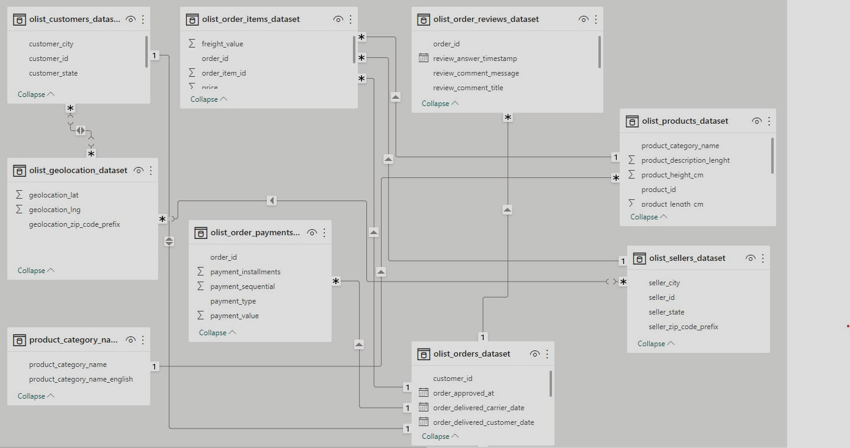

## **Plan of action**

* Task distribution among team members
* Data cleaning and preparation
* Exploratory Data Analysis
* Identifying correct visual formats(bar, line, pie, donut, histogram,maps,funnel etc)

and tools for text mining and polarity score generation.

* Visualisation and creating reports using Power BI Desktop to generate business insights individually by each member.
* Merging of reports and publishing on Power BI service to generate a dashboard.

**Proposed Reports for Dashboard:**

**Business Overview** to be prepared by Aqsa

* State Wise customer count
* Customer Location
* Yearly Sales and Order

**Sales** to be prepared by Iris

* Total Sales,Total Freight Value, Number of Orders, Number of Sellers
* Sales and Freight by Month
* Top product categories per year
* Bottom product categories per year
* Sales by Quarter
* Sales by State
* Sum of Payment Value by Payment Type

**Forecasting** to be prepared by Sujata

* Yearly Sales Trend
* Quarterly Sales and Order performance and 12-M forecasting.
* Monthwise Customer acquisition and Seller subscription status and 12-M forecasting

**Logistics** to be prepared by Stephy and Sujata

* Delivery and Order Status (On Time / Delayed/ delivered)
* Avg delivery time/dispatch time/processing time
* Actual and Estimated Delivery time
* Lists of states / products that has longer delivery period

**Quality** to be prepared by Stephy

* Bar chart between Sum of orders and Actual Delivery time, use average review_score to show the colour
* Average review scores
* Translate the comments and run a sentimental test on comments
* Word Cloud for keywords in comment
* Top categories by average review scores